FINAL PROJECT DOCUMENTATION
ServiceNow Incident Management Automation
Integrated Final Report – Five Project Phases and Implementation Evidence
Project Platform | ServiceNow
Primary Module | Incident Management
Business Scenario | Corporate VPN / Remote Access Incident
Completed Phases | Ideation, Requirement Analysis, Project Design, Project Planning, Project Development
Implementation Evidence | ServiceNow workspace screenshots and configuration screens
Document Purpose
This final document consolidates the five completed project phases with the actual ServiceNow implementation evidence shown in the supplied screenshots. It presents the project as one continuous lifecycle from idea and requirements through design, planning, development, testing, and final validation.

1. Executive Summary
The project implements a structured Incident Management lifecycle in ServiceNow to replace informal incident handling with a controlled process for incident creation, classification, knowledge assistance, assignment, escalation, change coordination, child-incident management, resolution, knowledge creation, and SLA tracking.
The project scenario focuses on a user who is unable to connect to the Corporate VPN from a home office. The implementation uses the Service Operations Workspace and demonstrates a complete incident journey involving the Service Desk, Level 2 support, knowledge articles, related records, a change request, and SLA information.
Final Result
The five project phases are connected into one implementation lifecycle, and the screenshots provide evidence of the configured ServiceNow records, service hierarchy, incident workflow, knowledge integration, assignment activity, related records, and SLA visibility.

2. Project Overview

2.1 Problem Statement
IT incidents may be reported through email, phone, or informal channels. Without a standardized workflow, incidents can be poorly classified, delayed in escalation, difficult to track against SLAs, and inconsistently documented for root cause and resolution.

2.2 Project Objective
The objective is to automate and standardize the Incident Management lifecycle using the ServiceNow Incident module, with integration to Knowledge Management, Change Management, related incidents, assignment groups, and SLA tracking.

2.3 Functional Scope
- Create incidents in Service Operations Workspace.
- Classify incidents using Category, Subcategory, Urgency, Service, Service Offering, and Configuration Item.
- Use Agent Assist and Knowledge Articles to support troubleshooting.
- Reassign incidents to appropriate support groups and Level 2 personnel.
- Create or coordinate an emergency change from the incident when required.
- Create child incidents for related user issues.
- Document probable cause, resolution code, and resolution notes.
- Create a Knowledge Article from a resolved incident.
- Track SLA and related records through the incident record.

3. Five Project Phases – Consolidated View
Phase | Purpose | Major Activities | Final Deliverable
Phase 1 – Ideation | Define the problem and project direction. | Problem statement, objectives, scope, stakeholders, milestones, expected benefits. | Approved project concept and scope.
Phase 2 – Requirement Analysis | Convert business needs into implementable requirements. | Functional, non-functional, stakeholder, service, data, SLA, and acceptance requirements. | Requirements baseline.
Phase 3 – Project Design | Design the target ServiceNow workflow and record relationships. | Service hierarchy, incident fields, knowledge, assignment, change, child incident, resolution, SLA design. | Solution design.
Phase 4 – Project Planning | Organize execution, testing, validation, resources, risks, and deployment. | Work breakdown, milestones, testing plan, validation plan, deployment and risk controls. | Project execution plan.
Phase 5 – Project Development | Configure and validate the solution in ServiceNow. | Service setup, incident lifecycle, knowledge, reassignment, Level 2, change, child incident, resolution, knowledge creation, validation. | Configured and tested ServiceNow workflow.

4. Phase 1 – Ideation Phase
The ideation phase established the business problem and defined the intended ServiceNow solution.
- Standardize incident creation and classification.
- Improve assignment and escalation to support teams.
- Integrate Knowledge Management with incident handling.
- Support emergency change creation from incidents.
- Support child incidents and knowledge creation after resolution.
- Improve service visibility and SLA compliance.

5. Phase 2 – Requirement Analysis
The requirement phase translated the project idea into concrete capabilities required in the ServiceNow environment.
- Incident creation with caller, description, channel, category, subcategory, urgency, service, service offering, and CI.
- Knowledge article search and attachment through Agent Assist.
- Reassignment to Level 2 groups and users.
- Emergency change integration and related-record visibility.
- Child incident creation and parent-child tracking.
- Resolution documentation and Knowledge Article creation.
- SLA and related-record validation.

6. Phase 3 – Project Design
The design phase defined how the required capabilities would work together.
- Service hierarchy: Remote Access → Corporate VPN.
- Incident lifecycle: New → classification → assignment/escalation → investigation → change/related work → resolution.
- Knowledge integration through Agent Assist.
- Assignment design for Service Desk and Network/Level 2 support.
- Related-record design for Change Request and Child Incidents.
- Resolution and Knowledge Article creation design.
- SLA visibility through Task SLAs / related records.

7. Phase 4 – Project Planning
The planning phase organized implementation into measurable milestones and defined how the workflow would be tested and validated.
- Plan service and service-offering configuration.
- Plan incident creation and classification validation.
- Plan knowledge, assignment, escalation, and Level 2 testing.
- Plan emergency change and child incident validation.
- Plan resolution, knowledge creation, and SLA verification.
- Plan deployment readiness and risk controls.

8. Phase 5 – Project Development
The development phase implemented the planned design in ServiceNow.
- Create Remote Access service and Corporate VPN service offering.
- Create and classify the Corporate VPN incident.
- Use Agent Assist to locate a VPN knowledge article.
- Assign and reassign the incident across support roles.
- Use related records for change and child incident management.
- Capture cause and resolution information.
- Create a Knowledge Article from the completed incident.
- Validate SLA and related-record visibility.

9. Actual ServiceNow Implementation Evidence
The following evidence section is based directly on the supplied screenshots. The figures are arranged to match the actual ServiceNow configuration and incident lifecycle shown in the project.

9.1 Service Configuration – Remote Access
The Service record is configured with the name Remote Access. The screenshot shows the service classified as a Business Service, used for Production, with Operational status set to Operational and business criticality set to 2 – somewhat critical.
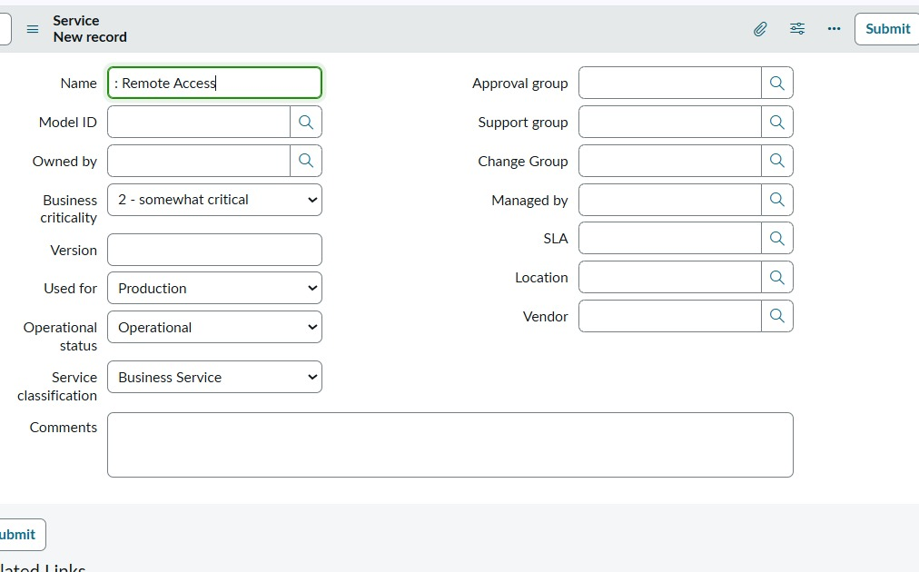
Figure 1. Remote Access service record configuration.

9.2 Service Offering – Corporate VPN
The Corporate VPN service offering is created under the Remote Access parent service. The screenshot shows Parent = Remote Access, Used for = Production, and Operational status = Operational.
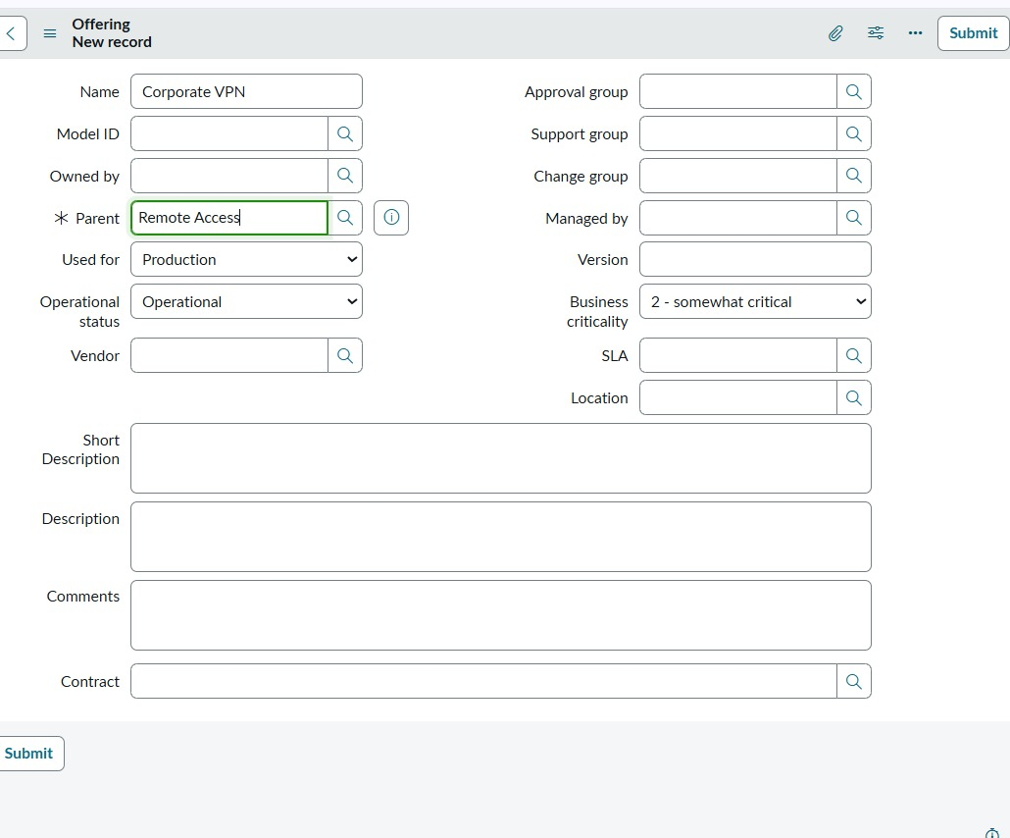
Figure 2. Corporate VPN service offering linked to Remote Access.

9.3 Incident Creation
The Service Operations Workspace shows creation of the incident with the short description 'Unable to connect to Corporate VPN from home office'. The caller is Michael Hoefer, the initial assignment group is Service Desk, and the incident begins in the New state.
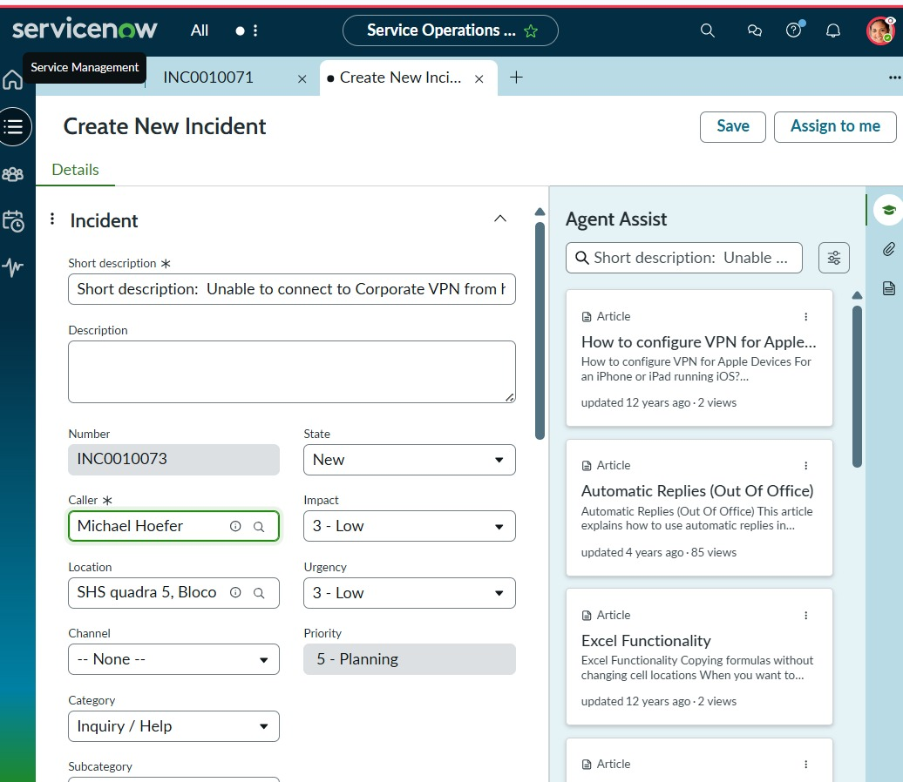
Figure 3. Create New Incident screen in Service Operations Workspace.

9.4 Incident Classification and Assignment
The incident is classified as a Network issue with medium urgency. The activity panel records field changes and assignment actions. The screenshots also show Service Desk assignment and an assigned user, demonstrating the transition from initial intake toward active investigation.
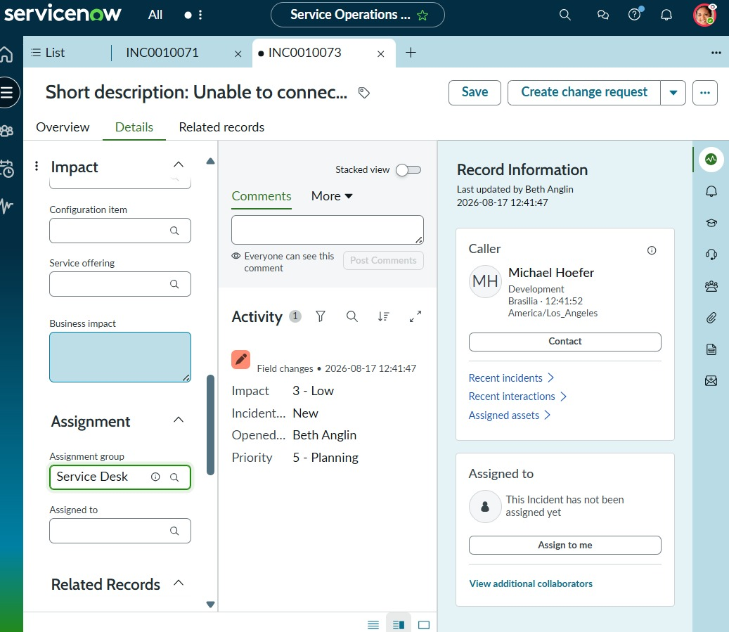
Figure 4. Incident classification, assignment group, and activity history.
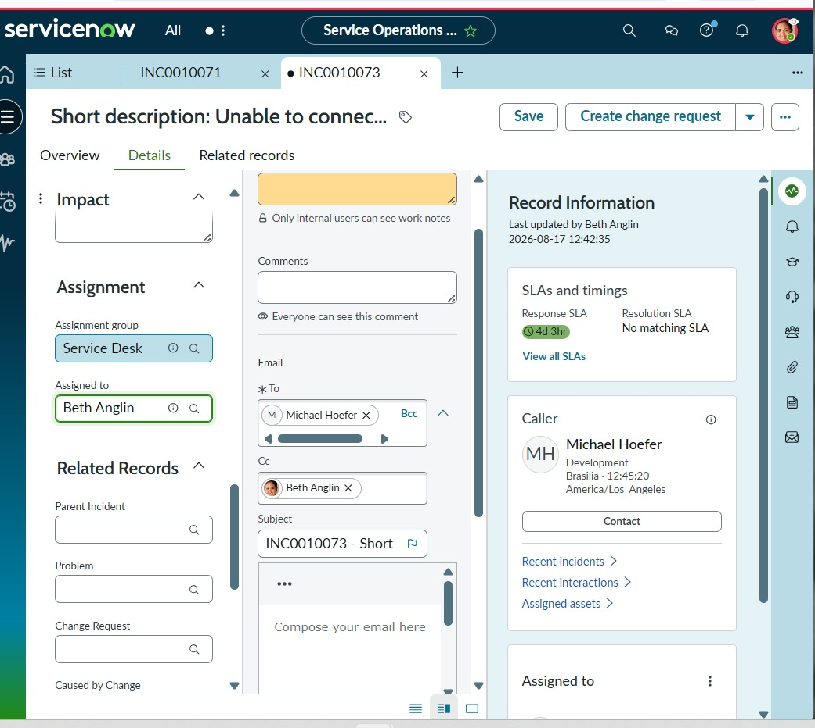
Figure 5. Incident assignment and communication/activity area.

9.5 Knowledge Integration with Agent Assist
Agent Assist displays knowledge suggestions relevant to the VPN incident. The supplied evidence shows the article 'How to configure VPN for Apple Devices' and the article can be opened from the workspace. This demonstrates the intended Knowledge Management integration.
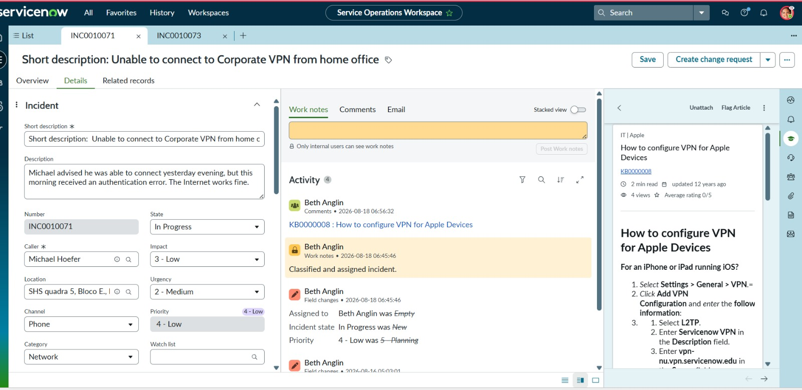
Figure 6. Agent Assist displaying a relevant VPN Knowledge Article.

9.6 Related Records and SLA Visibility
The incident's Related Records area provides fields for Parent Incident, Problem, Change Request, and Caused by Change. The right-side record information area also displays SLA information, including Response SLA and Resolution SLA where applicable.
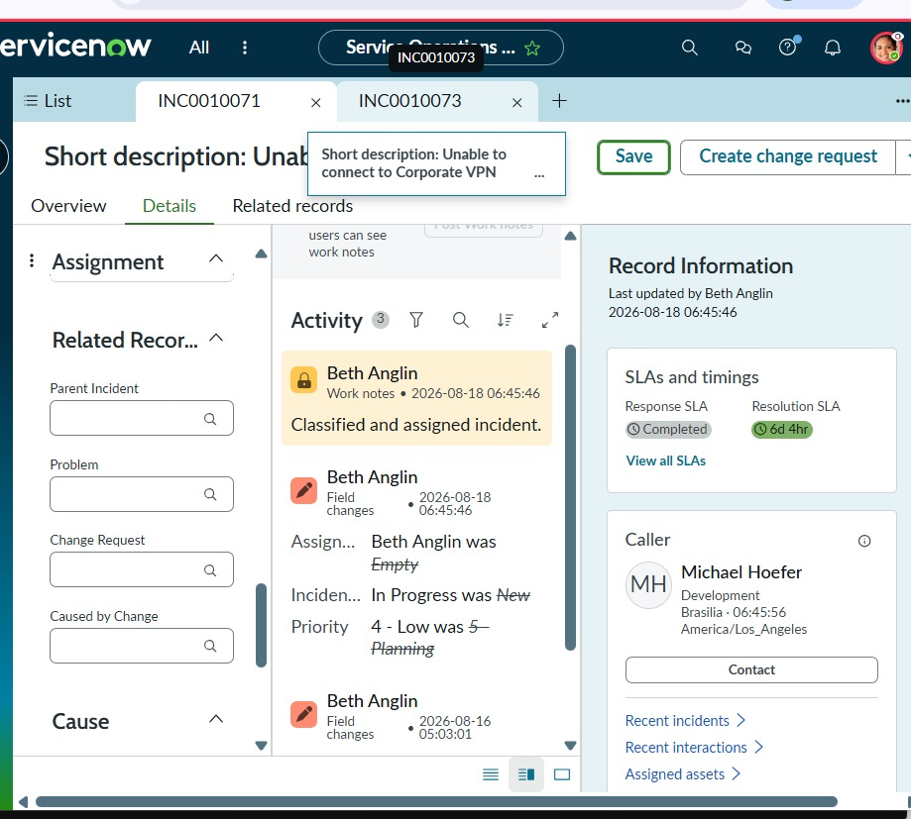
Figure 7. Related Records and SLA/timing information on the incident.

9.7 Level 2 Assignment and Incident Activity
The activity stream records assignment changes, including movement of the incident between users. In the supplied evidence, David Loo is shown as the current assignee during the investigation stage, while the activity history retains earlier assignment changes.
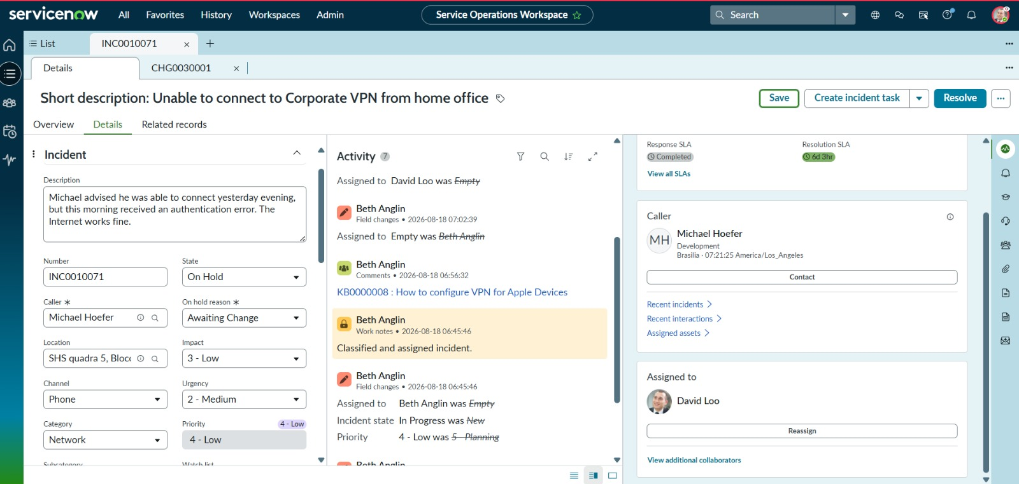
Figure 8. Level 2 assignment and incident activity history; the incident is shown in On Hold with Awaiting Change.

9.8 Change Coordination
The project workflow includes emergency change integration. The supplied incident evidence shows a Create change request action and the Related Records fields needed to maintain traceability between the incident and change activity.
Figure 9. Incident interface showing change-request action and related-record controls.

10. End-to-End Incident Management Workflow
- Service is configured: Remote Access.
- Service offering is configured: Corporate VPN.
- User incident is created in Service Operations Workspace.
- Incident is classified using network/VPN-related values, urgency, service, offering, and CI.
- Agent Assist searches for relevant knowledge articles.
- Incident is assigned to the Service Desk and can be escalated/reassigned to Level 2 support.
- Investigation is performed and related SLA information is monitored.
- If infrastructure/service change is required, the incident can be placed On Hold with Awaiting Change and associated with a change request.
- Related user issues can be represented through child incidents.
- Cause, resolution code, and resolution notes are recorded.
- The incident is resolved and the resolution is retained in the activity history.
- A Knowledge Article can be created from the resolved incident.
- Final validation confirms incident, child incident, change, knowledge, and SLA relationships.

11. Testing and Validation
Validation Area | Evidence / Expected Result
Incident creation | Verified through the Service Operations Workspace New Incident screen and incident number generation.
Incident classification | Verified through Channel, Category, Urgency, Service, and assignment fields shown in the incident interface.
Knowledge integration | Verified by Agent Assist displaying a VPN-related article and the article being visible in the workspace.
Assignment and escalation | Verified through Service Desk assignment and activity-history changes to assigned users/groups.
Level 2 investigation | Verified through assignment to a Level 2 user and visibility of incident activity and SLA information.
Change coordination | Verified through Create change request controls, Related Records, and the On Hold / Awaiting Change state.
Child incident management | Included in the designed lifecycle and related-record model for parent/child tracking.
Resolution | Included in the development workflow through cause, resolution code, and resolution notes.
Knowledge creation | Included in the final development and validation workflow.
SLA tracking | Verified through the SLA/timing panel visible in the supplied screenshots.

12. Final Project Deliverables
- Project Ideation Phase document.
- Requirement Analysis Phase document.
- Project Design Phase document.
- Project Planning Phase document.
- Project Development Phase document.
- This consolidated Final Project Documentation.
- ServiceNow implementation screenshots used as evidence.
- End-to-end Incident Management workflow and validation summary.

13. Final Outcome
The completed project demonstrates a structured ServiceNow Incident Management solution for Corporate VPN support. The five phases form a continuous project lifecycle: the ideation phase defines the business need, requirement analysis converts the need into requirements, design defines the solution structure, planning organizes execution and validation, and development implements the workflow in ServiceNow.
The supplied screenshots provide practical evidence of the implementation, including the Remote Access service, Corporate VPN service offering, incident creation, incident classification, Agent Assist knowledge support, assignment activity, SLA information, related records, and change-related incident handling.
Overall Project Outcome
The project establishes a traceable Incident Management process that connects Incident, Knowledge, Change, related records, assignment/escalation, and SLA tracking within ServiceNow. It supports a consistent operational lifecycle from incident intake through investigation and resolution.

14. Conclusion
This final documentation brings together the complete five-phase project and the implementation evidence into one clear report. The ServiceNow configuration and workflow shown in the screenshots align with the project objective of standardizing incident handling, improving support-team coordination, enabling knowledge reuse, maintaining related-record traceability, and supporting SLA visibility.
The final solution is presented as an end-to-end Incident Management implementation rather than as separate configuration steps. Each project phase contributes to the final operational workflow, making the documentation suitable for project submission, demonstration, review, and future maintenance.

Appendix A – Screenshot Evidence Index
- Figure 1: Remote Access service record.
- Figure 2: Corporate VPN service offering under Remote Access.
- Figure 3: Create New Incident screen.
- Figure 4: Incident details, classification, and assignment.
- Figure 5: Incident assignment and activity/communication evidence.
- Figure 6: Agent Assist and VPN knowledge article.
- Figure 7: Related Records and SLA/timing panel.
- Figure 8: Level 2 assignment and On Hold / Awaiting Change evidence.
- Figure 9: Change-request action and related-record controls.

Appendix B – Project Phase Traceability
Project Phase | What It Established | Where It Appears in Final Implementation
Ideation | Business problem, objectives, scope, stakeholders. | Overall incident-management purpose and VPN support scenario.
Requirement Analysis | Functional and non-functional needs. | Incident fields, knowledge, assignment, change, child incidents, resolution, SLA.
Project Design | Target workflow and record relationships. | Remote Access → Corporate VPN; incident → related records/knowledge/change/SLA.
Project Planning | Execution, testing, validation, deployment approach. | Validation matrix and end-to-end workflow.
Project Development | Actual ServiceNow configuration and testing. | Screenshots of service, offering, incident, Agent Assist, assignments, SLA, and related records.

